**Lab 6: Introduction to numerical simulations using Matlab/Simulink Environment**

650:361 Introduction to Mechatronics

Team Members: Shivani Topiwala, Nancy Contreras, and Pamela Pajarillo

**Introduction**

In this lab, we will investigate the response of control systems using Matlab and Simulink. We will simulate the open loop step response using the system of equations provided:

$\frac{dx_{1}}{dt} = -0.1x_{1}+0.1x_{2}$

$\frac{dx_{2}}{dt} = -0.2x_{2}+0.1u$

$y = x_{1}$

Using Simulink, we can find and verify that the transfer function is

$G(s) = \frac{0.01}{s^{2}+0.3s+0.02}$

**Task A: Open Loop Unit-Step Response using ODE model**

For this section, we plotted the response of the system given the unit step input *u(t)*

$u(t)=\left\{0, t <0 ; 1, t ≥ 0\right\}$

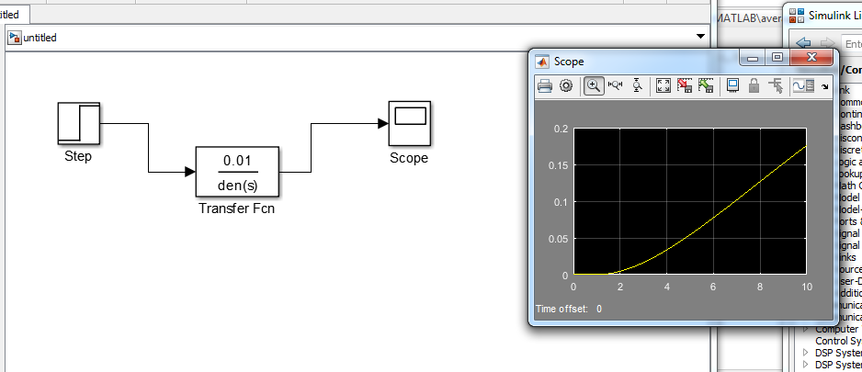

***Figure 1: Graph of the Transfer function***

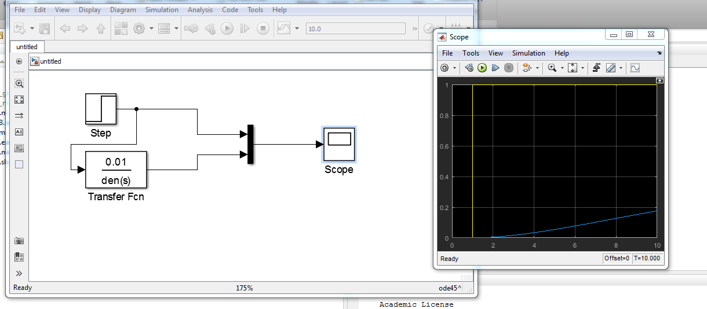

***Figure 2: Graph of Transform Function with Unit Step Function***

**Task B: Open Loop Unit- step Response using Transfer Function Model**

For this section, we created the same diagram, but the model was based on a transfer function block with a unit step input. We verified that the given transfer function is correct in the introduction section.

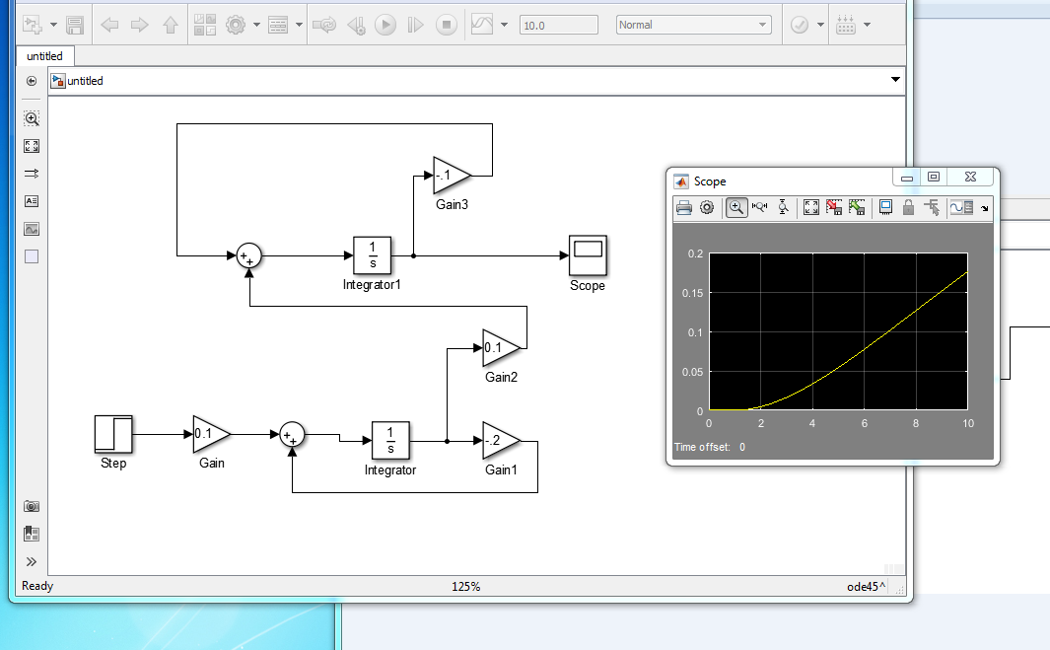

***Figure 3: Graph of the given system of equations***

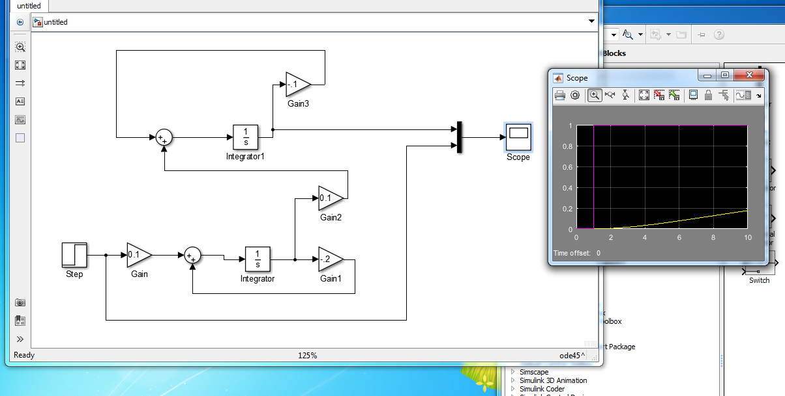

***Figure 4: Graph of given system of equations with unit step function***

Here we are comparing the unit step with the the above part, Task B.

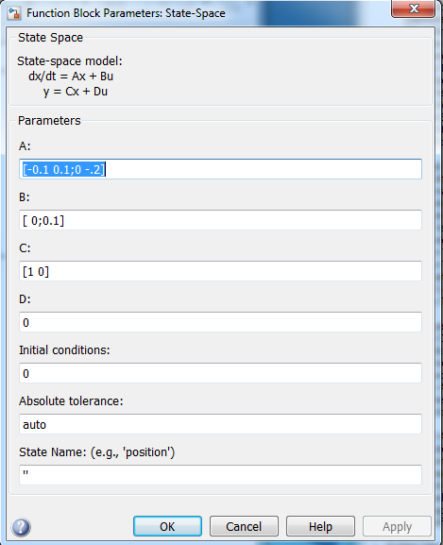

***Figure 5: State-Space Inputs to model given system of equations***

These are the inputs we used to model our system of equations that was given to us. This inputs were placed into the state-space block.

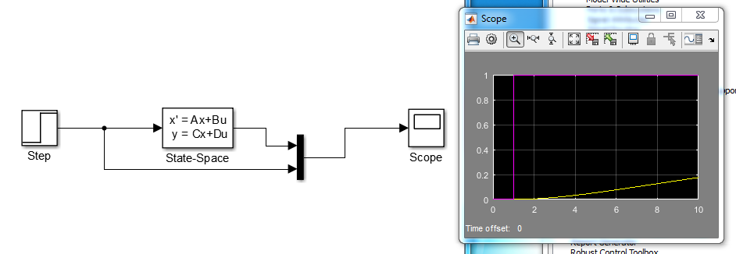

***Figure 6: Graph of state-space of given system of equations with unit step function***

Here we are comparing the graph of the state-space with the unit step.

**Conclusion**

In this lab, we were able to use Matlab and Simulink to analyze the response of control systems. We used mathematical concepts such as Laplace Transform in order to solve for the various system of equations that go into control systems. On Simulink, we were able to model and represent the input and output of control systems. We learned three different ways to model this system on Simulink.